PROJECT REPORT

ON

FEST MANAGEMENT SYSTEM

SUBMITTED BY:

PAVAN B

JITHENDRA Y

HARSHITH M

ACKNOWLEDGEMENT

*The success and final outcome of this project required a lot of guidance and assistance from many people and we are extremely privileged to have got this all along the completion of our project. All that we have done is only due to such supervision and assistance and we would like to thank prof. Preethi Khanna ma’am for the help.We would also like thank PhD Scholar Neha Gour for her guidance.*

*ABSTRACT*

*Fest management system is a project which aims in developing a computerised system to maintain the wholesome fest.*

*Many functionalities were included inorder to maintain the flow of the fest.*

*TABLE OF CONTENTS*

* *INTRODUCTION*
* *DATA TABLES*
* *ENTITY RELATIONSHIP DIAGRAM*
* *TECHNOLOGY USED*
* *OVERVIEW AND SCOPE*
* *INTRODUCTION*

*To explain it simply, we will discuss the purpose of it.*

*The purpose of this application are as follows :*

*• The software is for reducing paper work and digitalizing everything about the fest.*

*• It helps participants to easily access the information about the events and to register for them.*

* *DATA TABLES*

*The tables used are as follows:*

* *Admin*
* *Events*
* *User*
* *Participate*
* *Feedback*
* *Winners*

*The screenshots of the given tables are in the next folder.*

* *ER MODEL DIAGRAM*

*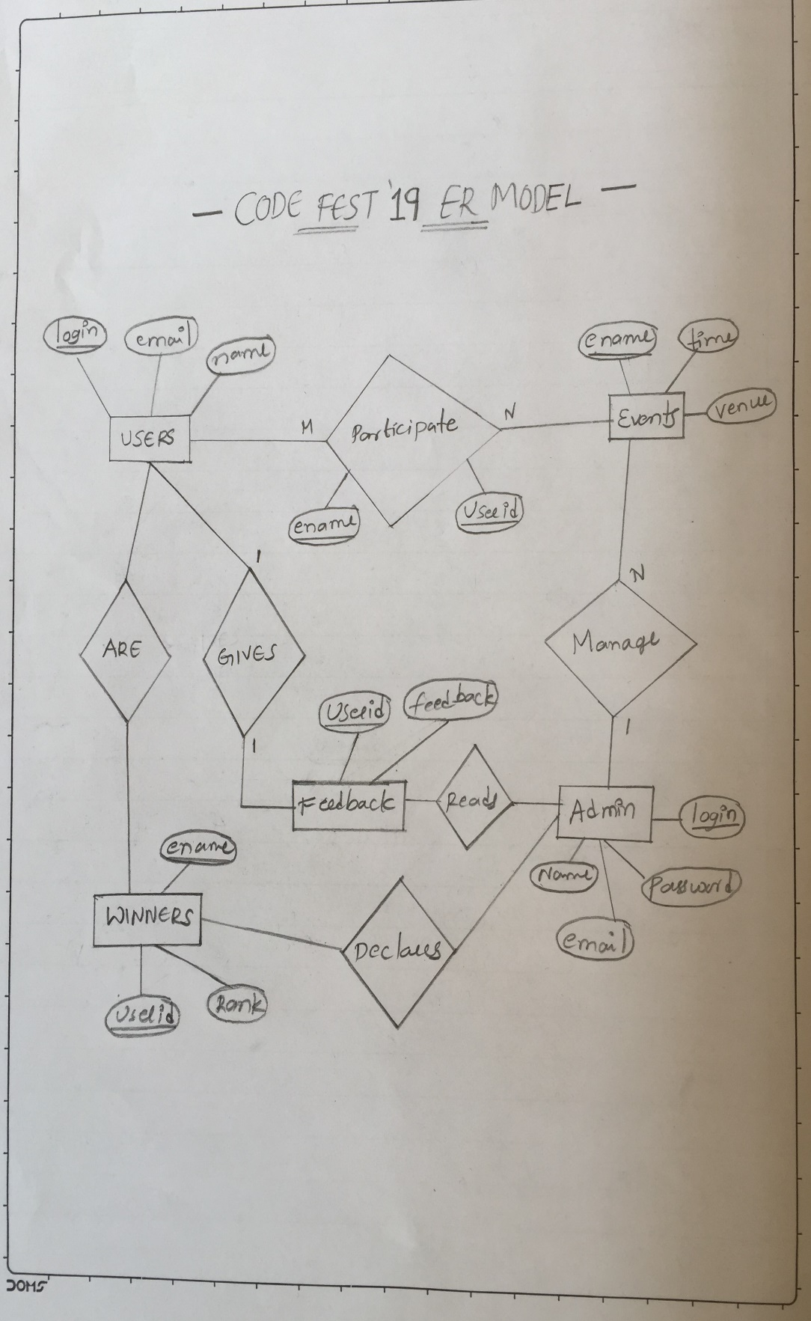*

* *TECHNOLOGY USED*
* *Front End : HTML ,CSS ,JavaScript*
* *Back End : Apache MySQL ,PHP*
* *OVERVIEW AND SCOPE*

*Project is related to FEST management which provides users to register for the fest, register to the events and keep track of the events .*

*Anyone can become a participant of the CODEFEST’19 by filling a Register form.*

*They can add upto 3 events per day.*

*Winners are declared by Admin in the webpage.*

*Any institute or organisations conducting fests can use this type of management system.*